**Harnessing the Power of Generative AI for Personalized Financial Planning and Advice.!**

**Introduction:**

Personalized financial advice is crucial because everyone’s financial situation is unique. leverages Large Language Model (LLM’s) to create a personalized financial planning assistant for bank customers.

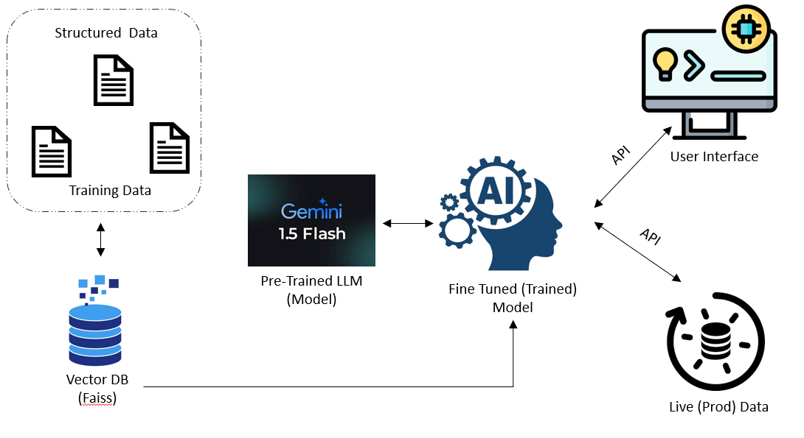

* **Synthetic Data (Training data)**: Used customer profile, social media activities, banking transaction data sets to train the model
* **LLM Model**: gemini 1.5 flash
* **Vector DB** : Faiss
* **Model Fine tuning**: Fine tune the AI model using the Factors like customer’s profile, age, Job, location, income, savings, expense, loan, financial goal, preference, interest, banking transaction, and purchase history to determine the best financial strategies for an individual.
* **Personalized Recommendations**: Tailored to the user’s unique financial situation, profile, and goals, the AI generates personalized advice and recommendations such as:

Saving plan

Investment strategies

Risk-based investment opportunities

Insurance advises

Debt Management and repayment plans

Credit card.

* **Generative Content Creation:** The AI can create easy-to-understand reports explaining complex financial concepts. It can also generate personalized financial guides with charts and graphs for better visualization.
* **Conversational Interface:** A chatbot powered by generative AI acts as a financial advisor, answering user questions and providing guidance. The chatbot adjusts its language and explanations based on the user’s financial literacy.

**Benefits of a Personalised**

* **Enhanced Customer Experience**: Personalized financial guidance empowers customers to make informed decisions.
* **Increased Financial Literacy**: Educational tools and clear explanations improve financial understanding.
* **Improved Sales & Retention**: Proactive assistance strengthens customer relationships and leads to targeted financial product recommendations.
* **Data-Driven Decision Making**: AI simulations enable better risk assessment and informed financial planning.

**UI Page And User Flow :**

**AI Login Page**

1. The login page provides a seamless and secure authentication experience for users.

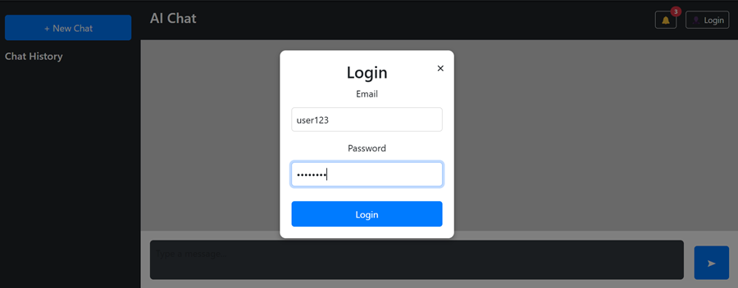

1. AI Chat home page serve as the central hub for users to engage with an intelligent, conversation AI assistant. Designed for ease of use, efficiency, and personalization, the home page provides seamless access to AI powered chat interaction

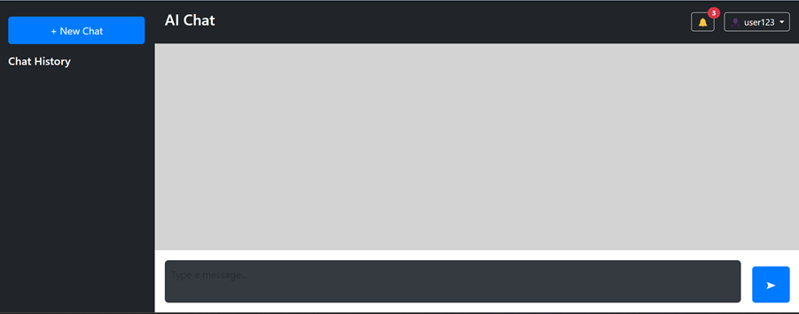

1. The Notification Module in AI chat ensures users stay informed about important updates, messages, and system alerts in real-time. Designed for efficiency and user convenience, it offers customizable notifications based on user preferences and interaction patterns.

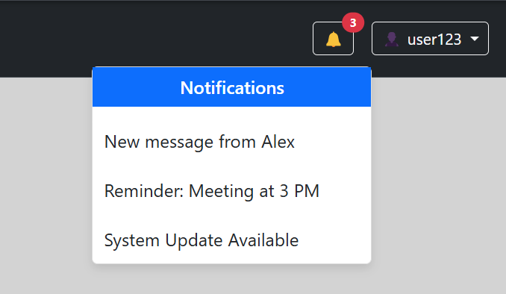

1. The New Chat & History Module in AI chat enables users to start fresh conversations and access past interactions seamlessly. Designed for efficiency, personalization, and security, this module enhances user experience by organizing chat sessions effectively.

